Project Title
HOSPITAL BED/OR SCHEDULING SYSTEM
Project Report submitted for the partial fulfilment of grade for the course

Data Structures and Algorithms -3 (25CS2103E)
in

A.Y. 2026-2027

Submitted by
V.Sathvik 2520090097
CH.Shanthi Swaroop 2520090224

Team Number: 1
Section: 10

Under the guidance of

DR. K.Chandusha
Professor, CSIT


Hyderabad-500090, Telangana, India.

K L (Deemed to be) University
DEPARTMENT OF COMPUTER SCIENCE AND INFORMATION TECHNOLOGY



DECLARATION

The Mini Project Report entitled “Hospital Bed/OR Scheduling System” is a record of Bonafide work of V. Sathvik – 2520090097, Ch. Shanthi Swaroop - 2520090224 submitted in partial fulfillment for the award of B. Tech in Computer Science and Information Technology The results embodied in this report have not been copied from any other departments/University/Institute.

V. Sathvik - 2520090097
CH.Shanthi Swaroop - 2520090224

K L (Deemed to be) University
DEPARTMENT OF COMPUTER SCIENCE AND INFORMATION TECHNOLOGY
CERTIFICATE

This is to certify that the mini project based report entitled “Hospital Bed/OR Scheduling System” is a bonafide work done and submitted by V.Sathvik (2520090097), Ch.Shanthi Swaroop (2520090224) in partial fulfillment of the requirements for the award of the degree of BACHELOR OF TECHNOLOGY in Department of Computer Science Engineering/ Computer Science and Information Technology/Artificial Intelligence & Data Science, K L (Deemed to be University), during the academic year 2026-2027.

Signature of the Supervisor

Signature of the HOD Signature of the External Examiner

ACKNOWLEDGEMENT

The success in this project would not have been possible but for the timely help and guidance rendered by many people. Our wish to express my sincere thanks to all those who has assisted us in one way or the other for the completion of my project.

Our greatest appreciation to my guide, DR.K.Chandusha,Professor,CSIT which cannot be expressed in words for his/her tremendous support, encouragement and guidance for this project.

We express our gratitude to Dr. Khaja Shareef (CSIT) Head of the Department for Computer Science and Information Technology providing us with adequate facilities, ways and means by which we are able to complete this project-based Lab.

We thank all the members of teaching and non-teaching staff members, and also who have assisted me directly or indirectly for successful completion of this project. Finally, I sincerely thank my parents, friends and classmates for their kind help and cooperation during my work.

V. Sathvik 2520090097
Ch. Shanthi Swaroop 2520090224

TABLE OF CONTENTS

S.No. | Contents | Page no.
1. | Abstract
2. | Introduction
3. | Literature survey
4. | Problem Statement and Objectives
5. | Hardware and Software requirements
6. | Implementation
7. | Results & Discussion
8. | Conclusion & Future Scope
9. | References

1.ABSTRACT

The Hospital Bed and Operating Room (OR) Scheduling System is designed to improve the efficiency of hospital resource management by optimizing the allocation and scheduling of hospital beds and operating rooms. The system automates scheduling by considering patient admissions, surgery priorities, bed availability, operating room capacity, and medical staff availability. It aims to minimize scheduling conflicts, reduce patient waiting times, and improve the utilization of essential healthcare resources.
The proposed application provides real-time monitoring of bed occupancy, patient admissions, and surgery schedules, enabling hospital administrators to make timely and informed decisions. It supports efficient coordination between departments and helps medical staff manage patient care more effectively. By maintaining accurate patient records and scheduling information, the system reduces manual paperwork, minimizes administrative errors, and improves overall operational efficiency.
Developed using modern software technologies and database management systems, the application ensures secure data storage, reliable information retrieval, and efficient management of hospital resources. It also supports better decision-making during emergencies by helping administrators identify available beds and operating rooms quickly. Furthermore, the system offers scalability, allowing hospitals to adapt its functionality according to their changing requirements. Overall, the Hospital Bed and OR Scheduling System provides a reliable, organized, and efficient solution for modern healthcare facilities, enhancing resource utilization, improving patient care, and supporting effective hospital administration.

Team Name: HOSPITAL BED/OR SCHEDULING SYSTEM
Team Members:
- [V.Sathvik,2520090097]
- [CH.Shanthi Swaroop,2520090224]

- INTRODUCTION

Hospital resource management is an essential part of providing effective and timely healthcare services. Hospitals often face challenges in managing bed availability, patient admissions, operating room schedules, surgery priorities, and medical staff availability. Traditional manual scheduling methods can lead to delays, scheduling conflicts, inefficient resource utilization, and increased administrative workload.
The Hospital Bed and Operating Room (OR) Scheduling System is developed to address these challenges by automating and simplifying the scheduling process. The system helps hospital administrators allocate beds and operating rooms based on patient requirements, surgery urgency, resource availability, and staff schedules. It provides an organized platform for monitoring bed occupancy, managing surgery schedules, and maintaining accurate patient records. By integrating modern software technologies with database management systems, the application improves data accuracy, coordination, and operational efficiency. The system also supports faster decision-making during emergencies by providing updated information about available resources. Overall, this project aims to enhance hospital management, reduce patient waiting times, optimize resource utilization, and improve the quality of patient care.
Furthermore, the system helps improve communication and coordination among hospital departments, including admission units, operation theatres, and medical staff. By maintaining centralized and updated information, administrators can quickly identify available beds, review upcoming surgeries, and manage changes in schedules whenever necessary. This reduces the possibility of double booking, delays, and confusion during critical situations. The system can also help prioritize emergency cases and ensure that hospital resources are assigned according to patient needs and medical urgency.
The proposed system is designed to be user-friendly, reliable, and scalable to meet the requirements of hospitals of different sizes. It provides a structured approach to handling scheduling activities while reducing dependency on manual record-keeping. Secure database management helps maintain patient information and scheduling records accurately. In the future, the system can be enhanced with advanced features such as automated notifications, predictive resource planning, and intelligent scheduling algorithms. These improvements can further increase efficiency, reduce operational costs, and support better healthcare service delivery. Thus, the project contributes to developing a more organized, responsive, and technology-driven hospital management environment.

3.LITERATURE SURVEY
Here is a ready-to-use Literature Survey and References section for your Hospital Bed / Operating Room (OR) Scheduling System project documentation. It includes 10 similar existing software systems, with a short explanation of each and its website URL.

1. GE HealthCare – Centricity Perioperative Software
GE HealthCare's Centricity Perioperative software supports operating room scheduling and surgical resource management. It helps hospitals coordinate operating rooms, patient care activities, and medical staff. The system provides real-time visibility into perioperative resources and surgical progress. It also supports reporting and management of perioperative workflows.

2. Getinge – Torin OR Management
Torin OR Management is designed to improve operating room planning and utilization. It uses intelligent scheduling capabilities to help coordinate surgical procedures and available resources. The platform provides real-time surgery progress updates and performance analysis. It aims to improve scheduling accuracy, reduce inefficiencies, and support better surgical department management.

3. ORS AI – Operating Room Scheduling Software
ORS AI focuses on operating room scheduling, perioperative coordination, and operating room analytics. It helps hospitals monitor surgical schedules, identify potential delays, and manage operating room utilization. The platform provides schedule updates and operational insights to support decision-making. Its main objective is to reduce idle time and improve coordination across surgical departments.

4. iHospital365 – Inpatient Department Management
iHospital365 provides inpatient department management features, including bed allocation, ward occupancy tracking, and operating theatre scheduling. It helps hospitals manage patient admissions and room assignments while coordinating nursing workflows. The system also supports billing and insurance-related activities. These features can improve visibility into available beds and streamline inpatient operations.

5. ZenoHosp – Hospital Management System
ZenoHosp is an integrated hospital management platform that includes patient registration, inpatient management, and operating theatre scheduling. It supports operating room availability management and surgical team coordination. The platform combines different hospital departments within a centralized system. This approach can reduce repeated data entry and improve the coordination of hospital resources.

6. Ostron HMIS – Hospital Management Information System
Ostron HMIS offers hospital management features such as bed management, inpatient admission and discharge, and operating theatre management. Its bed management module helps staff monitor ward occupancy and bed status. The system also supports nursing documentation, laboratory operations, billing, and other hospital activities. Its integrated approach provides a useful reference for developing centralized hospital resource management software.

7. HD MediDesk – Hospital Management System
HD MediDesk combines inpatient and outpatient management with bed and ward management and operating theatre scheduling. It provides information about occupied and vacant beds to support resource allocation. The platform also integrates staff operations and financial reporting. These capabilities demonstrate how a unified application can improve hospital workflow management and reduce the need for disconnected manual processes.

8. Uyirly – Hospital Management Software
Uyirly is a hospital management platform that connects patient registration, inpatient management, ward operations, and operation theatre services. It supports bed management and scheduling through an integrated software environment. Its centralized approach helps hospital departments access relevant operational information. The platform serves as a reference for designing a system that maintains organized records and improves coordination among hospital departments.

9. KeyCode Technology – Hospital Management Software
KeyCode Technology provides hospital management software with modules for inpatient care, ward and bed management, and operating theatre scheduling. The system supports bed allocation, admission and discharge management, and surgical resource coordination. It also integrates pharmacy, laboratory, and billing functions. These features provide a useful reference for developing a hospital scheduling application that combines multiple operational requirements in one platform.

10. Tapti HMIS – Hospital Management Information System
Tapti HMIS integrates inpatient management, surgery-related workflows, billing, and other hospital operations. Its inpatient management capabilities include bed shifting, patient records, and discharge-related activities. The platform supports configurable workflows to accommodate different hospital requirements. It provides a reference for building a scalable system that improves resource allocation, maintains accurate information, and coordinates hospital operations efficiently.

The following URLs correspond to the existing software systems discussed in the literature survey.
1. GE HealthCare – Centricity Perioperative Software: https://www.gehealthcare.com/en-in/products/healthcare-it/perioperative-software
2. Getinge – Torin OR Management: https://www.getinge.com/int/products/torin/
3. ORS AI – Operating Room Scheduling Software: https://orsai.app/
4. iHospital365 – Inpatient Department Management: https://ihospital365.com/features/ipd/
5. ZenoHosp – Hospital Management System: https://www.zenohosp.com/
6. Ostron HMIS – Hospital Management System: https://hmis.ostron.in/
7. HD MediDesk – Hospital Management System: https://www.hdmedidesk.com/
8. Uyirly – Hospital Management Software: https://www.uyirly.com/
9. KeyCode Technology – Hospital Management Software: https://keycodetech.com/products/hospital-management
10. Tapti HMIS – Hospital Management System: https://taptitechnology.com/
The reviewed systems demonstrate that hospital bed management and operating room scheduling can be integrated into digital hospital management platforms. However, the features, accessibility, and implementation requirements vary between products. Our proposed project aims to develop a unified, user-friendly application that combines bed availability tracking, patient admission management, surgery prioritization, and operating room scheduling. It will focus on reducing scheduling conflicts, improving resource utilization, and helping hospital administrators make timely decisions.

- Problem Statement and Objectives

Problem Statement: Inefficient hospital bed and operating room scheduling causes patient delays, resource wastage, and scheduling conflicts.
Problem Description: Hospitals often struggle to coordinate bed availability, patient admissions, surgery priorities, and medical staff schedules. These challenges can cause delays, resource wastage, and difficulties in providing timely patient care
Objectives:
• Automate Scheduling: Simplify and automate hospital bed allocation and operating room scheduling.
• Reduce Waiting Time: Minimize patient waiting times by improving scheduling efficiency.
• Optimize Resource Utilization: Ensure effective utilization of available beds, operating rooms, and medical staff.
• Prevent Scheduling Conflicts: Avoid double bookings and overlapping surgery schedules.
• Real-Time Monitoring: Provide updated information about bed occupancy and operating room availability.
• Improve Decision-Making: Help hospital administrators prioritize emergency cases and make timely decisions.
• Maintain Accurate Records: Store and manage patient, admission, and surgery scheduling information securely.
• Enhance Patient Care: Improve hospital workflow and support timely, efficient healthcare services.

- HARDWARE AND SOFTWARE REQUIREMENTS

Hardware Requirements
- Processor: Intel Core i3 or above
- RAM: Minimum 4 GB (8 GB recommended)
- Hard Disk: Minimum 256 GB HDD/SSD
- Display: Standard monitor with 1366 × 768 resolution or higher
- Input Devices: Keyboard and mouse
- Internet: Stable internet connection for web application access

Software Requirements
- Operating System: Windows 10/11 or Linux
- Frontend: HTML, CSS, JavaScript
- Backend: Python with Flask or Node.js with Express
- Database: MySQL
- Code Editor: Visual Studio Code
- Web Browser: Google Chrome or Microsoft Edge
- Server: Flask development server or Node.js server
- Design Tools: Figma or Draw.io for UI and system diagrams

- IMPLEMENTATION

CO-1 :
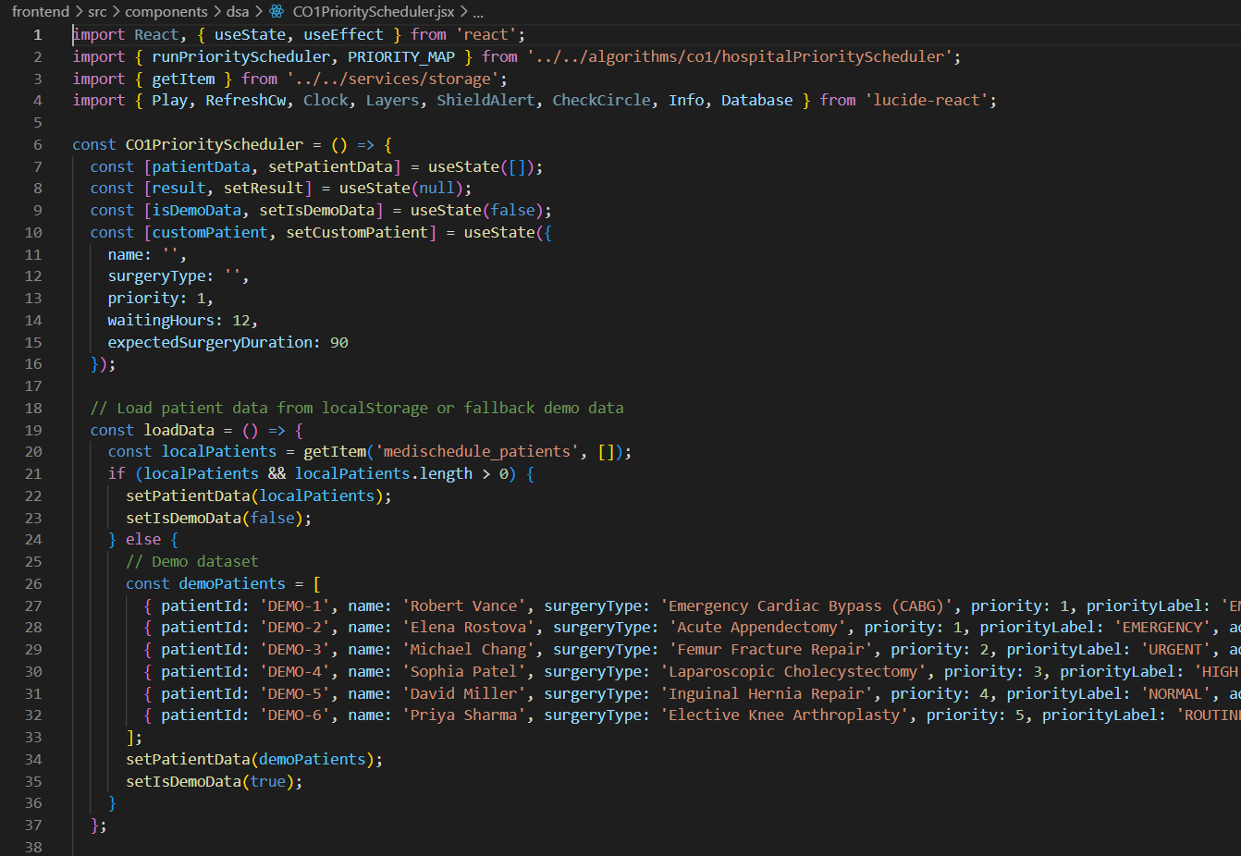
CO-2 :
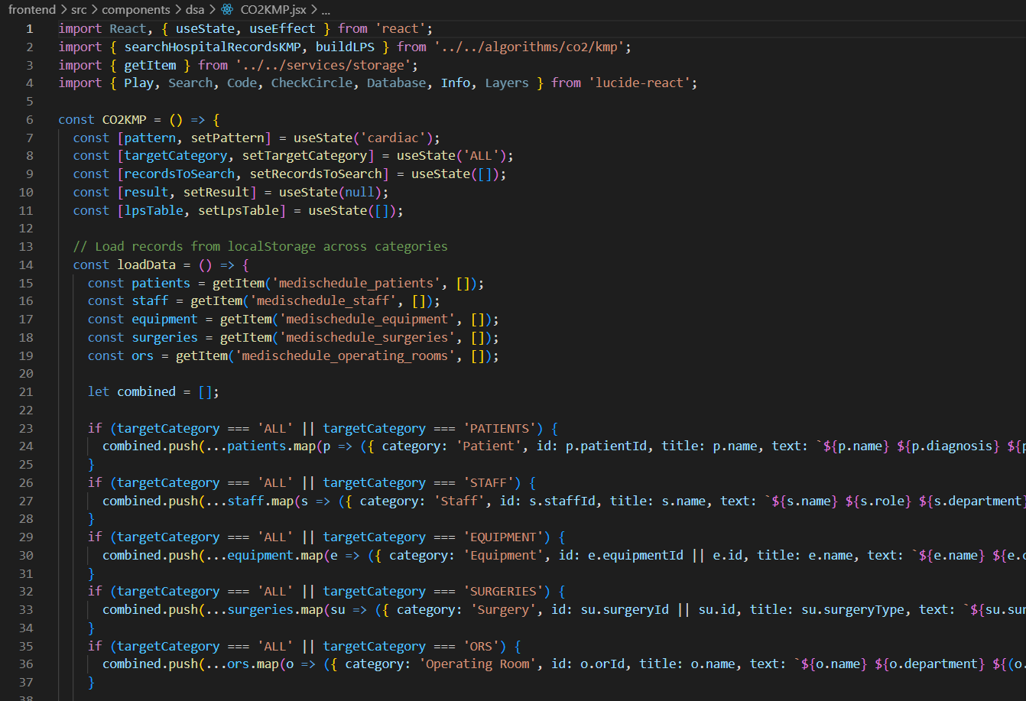

CO-3 :
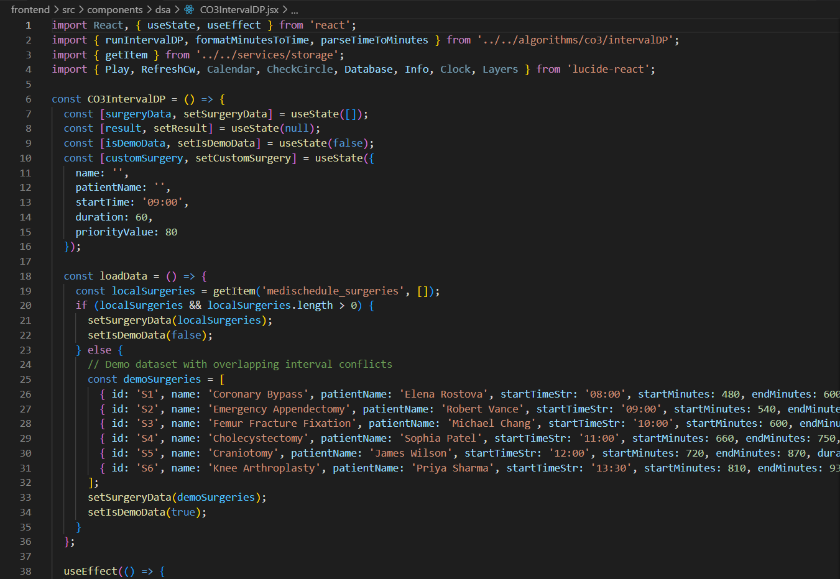
CO-4 :
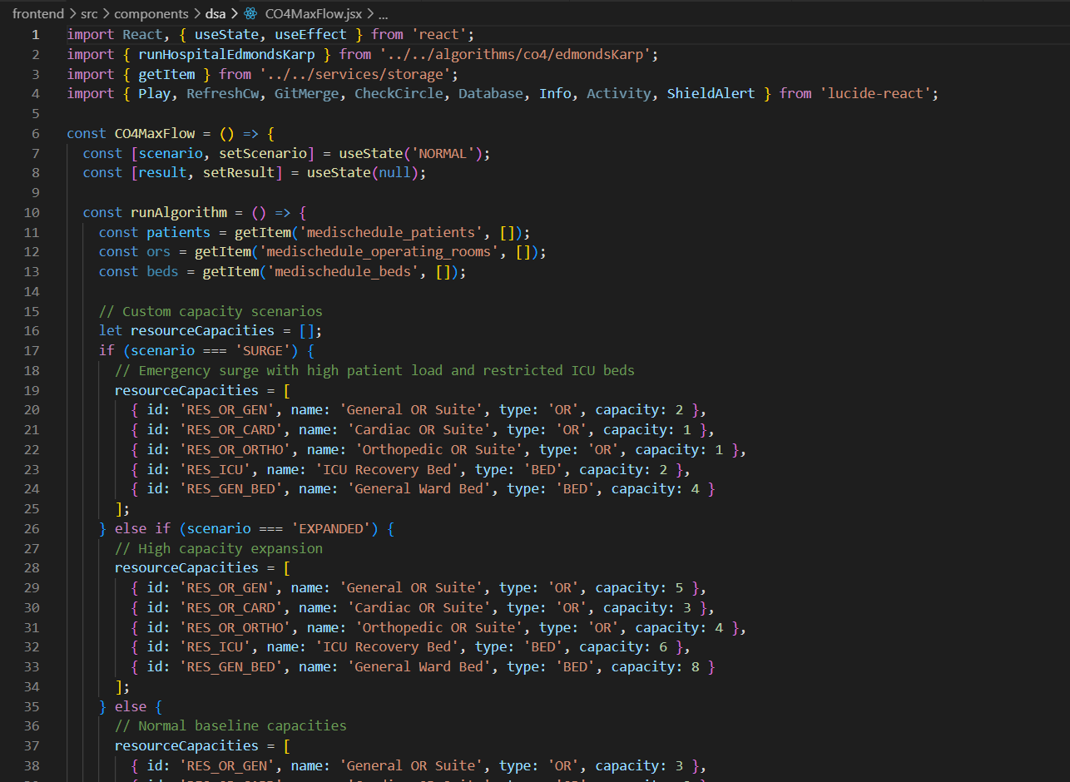

CO-5 :
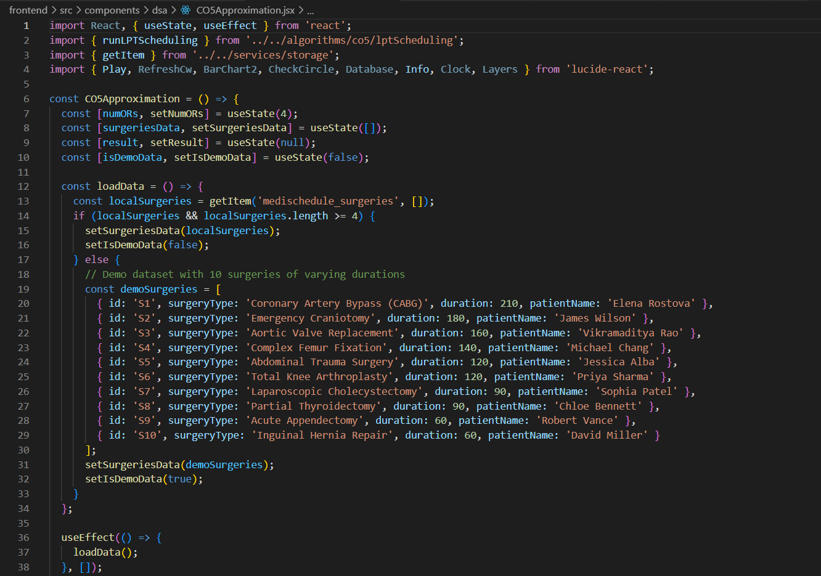

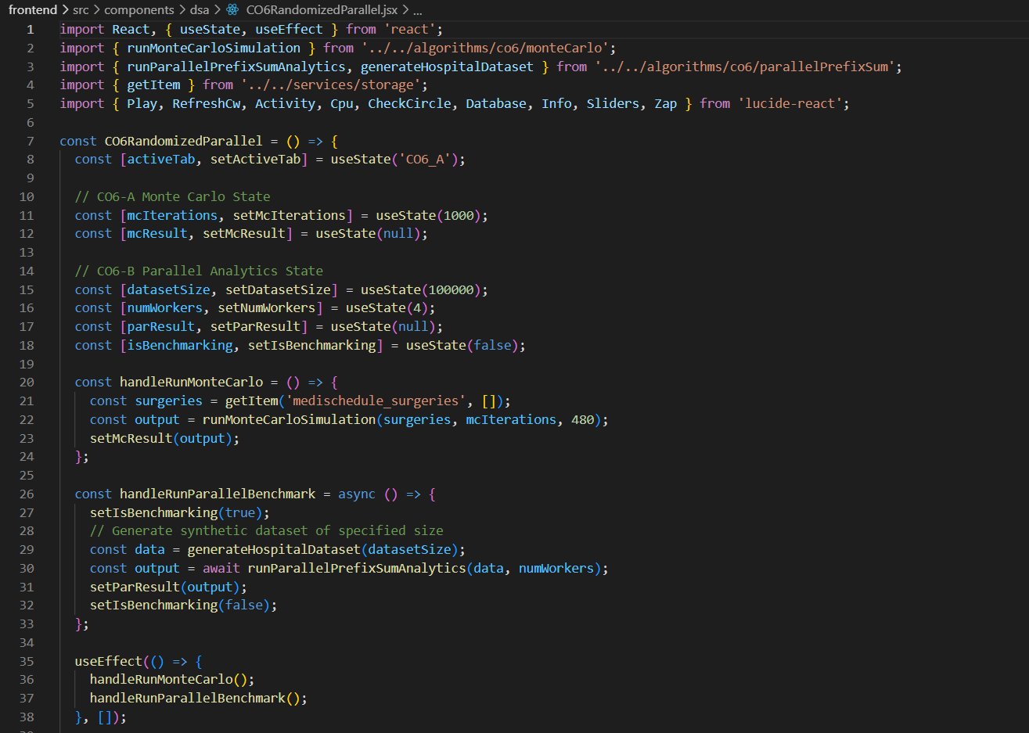
CO-6 :

- RESULTS & DISCUSSION
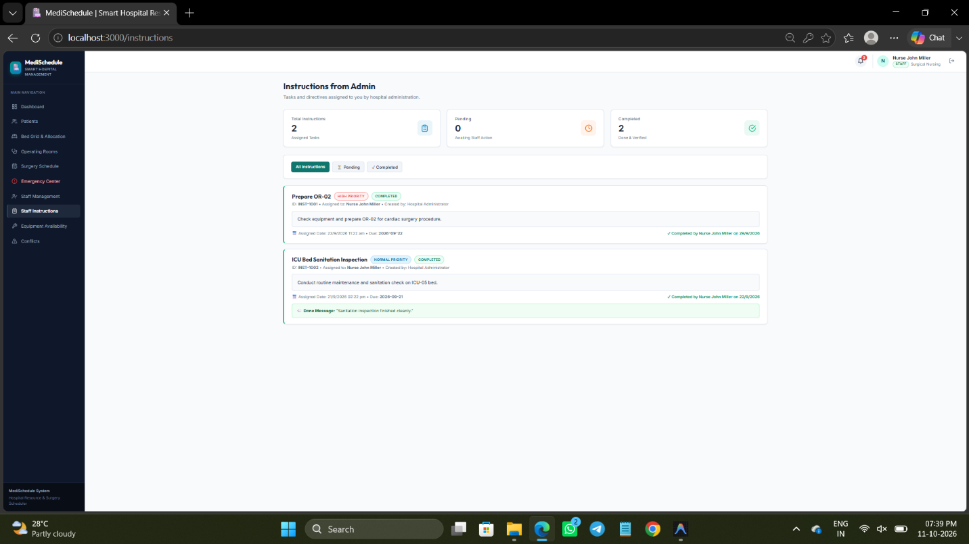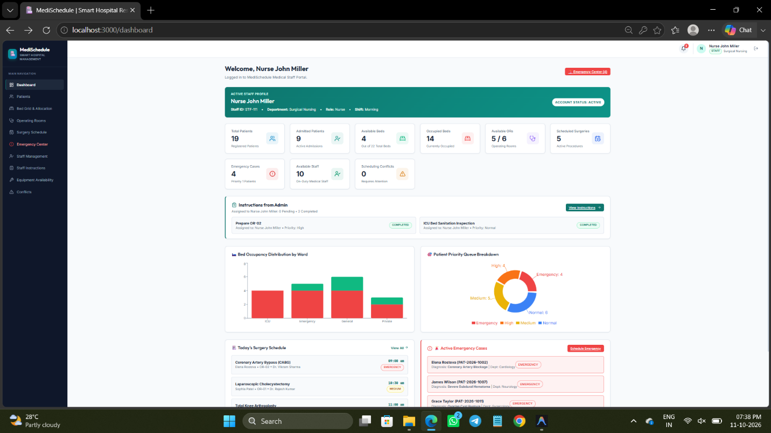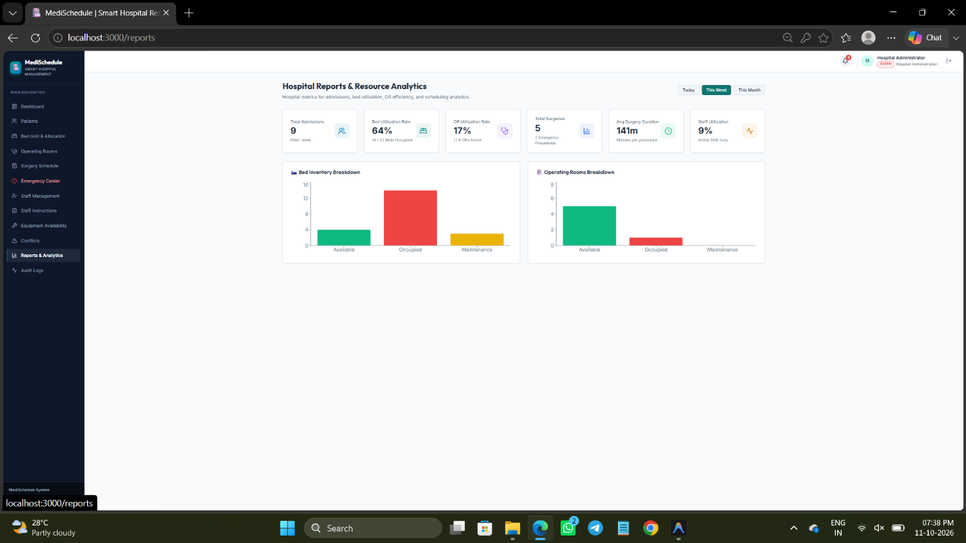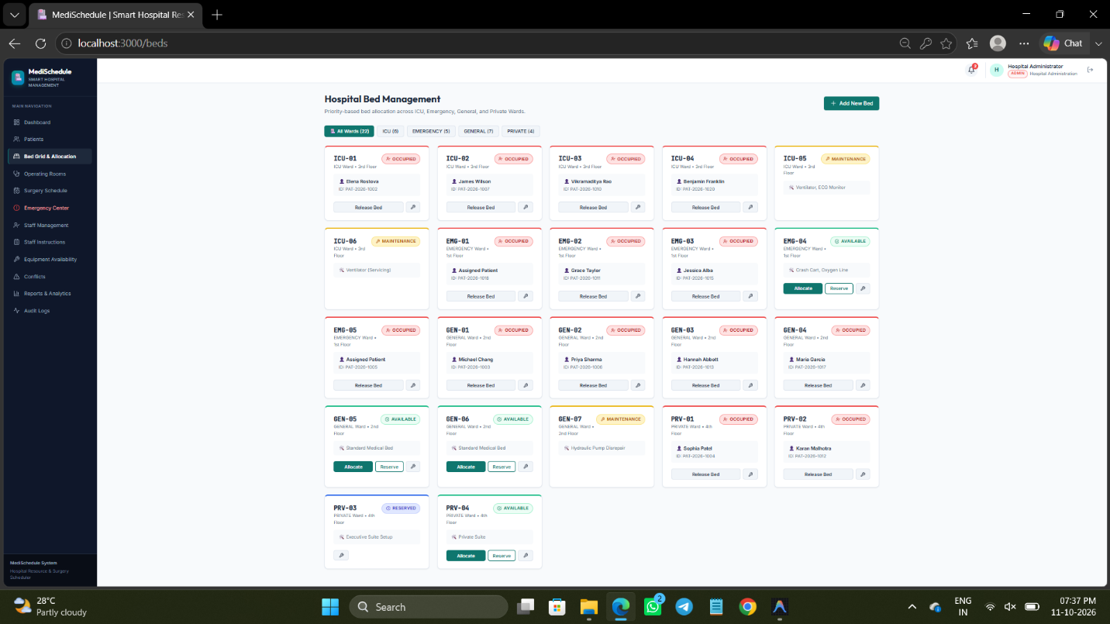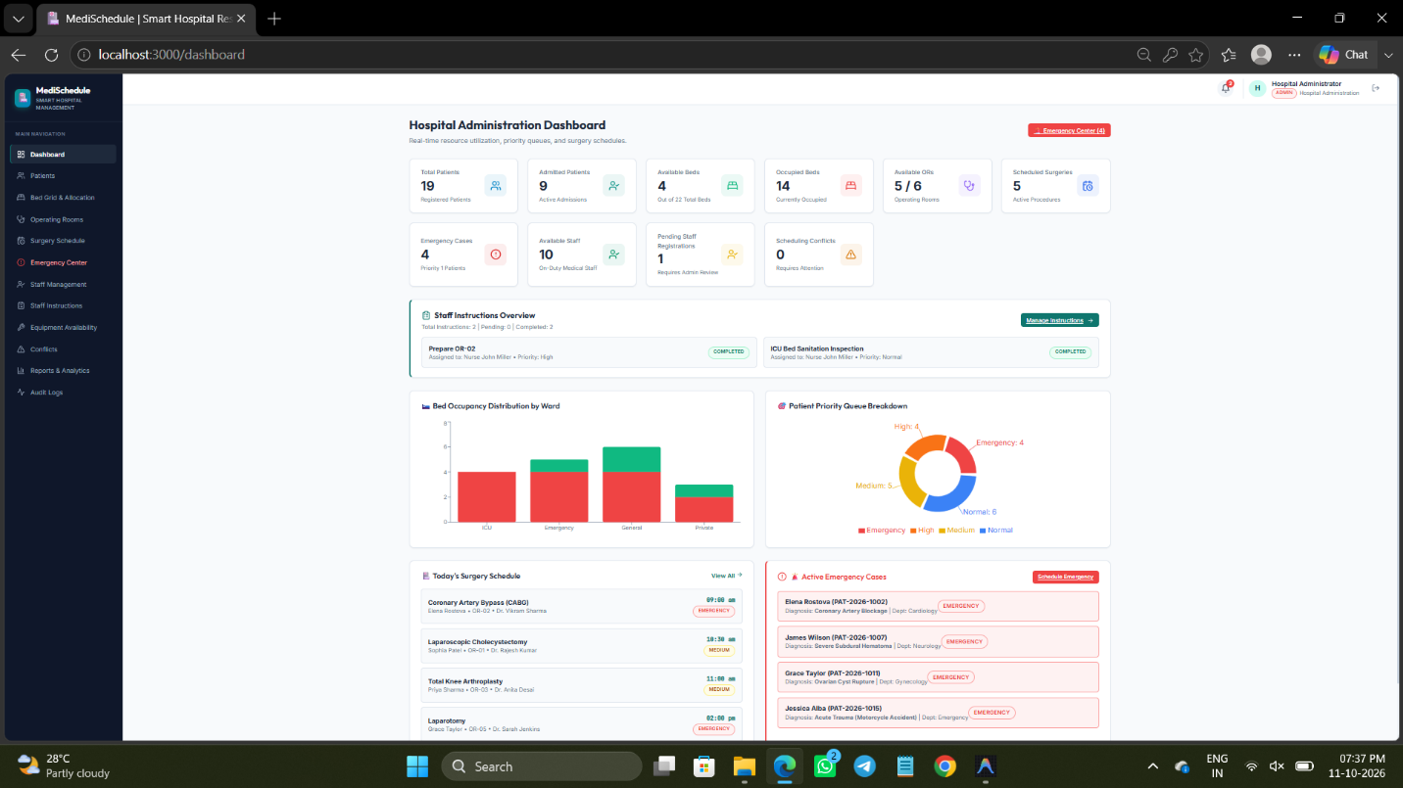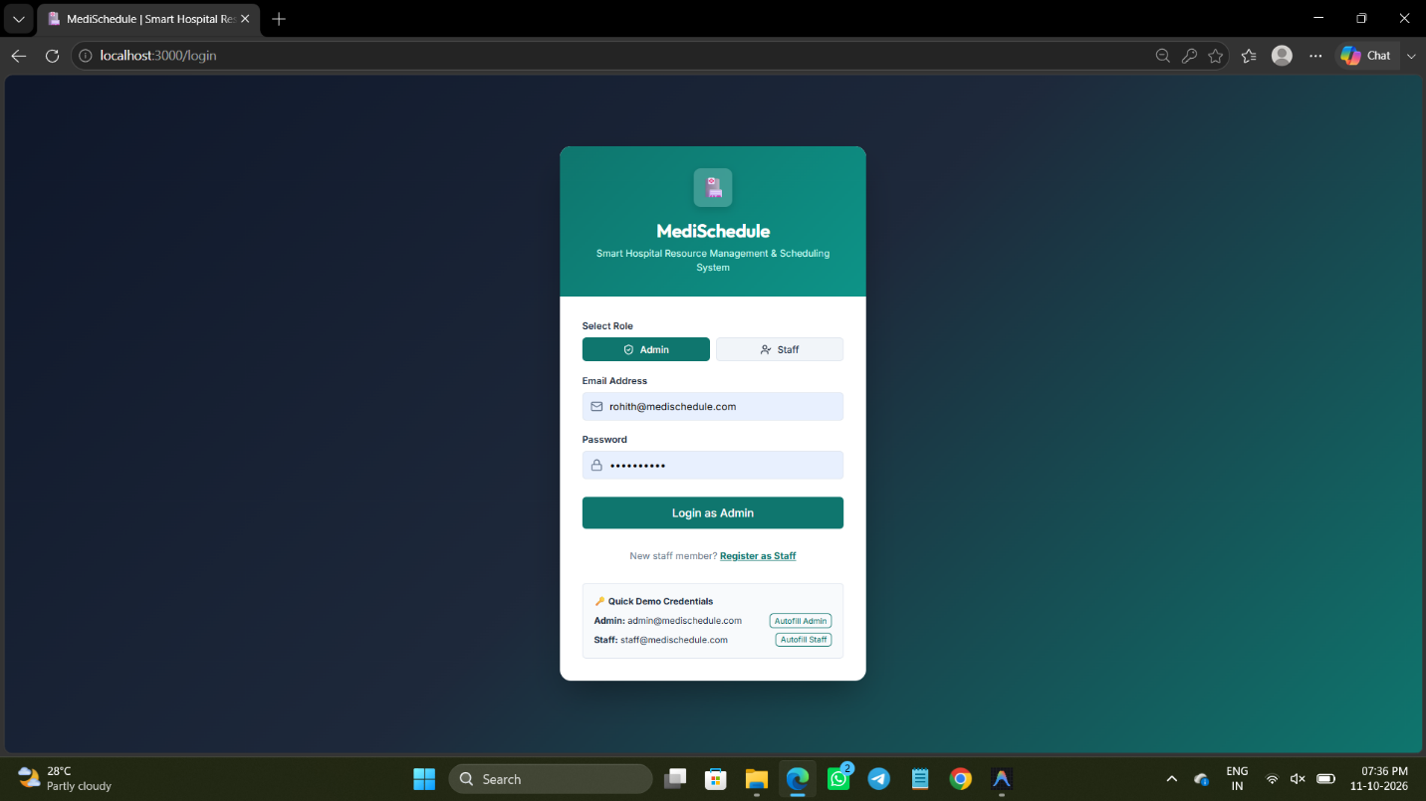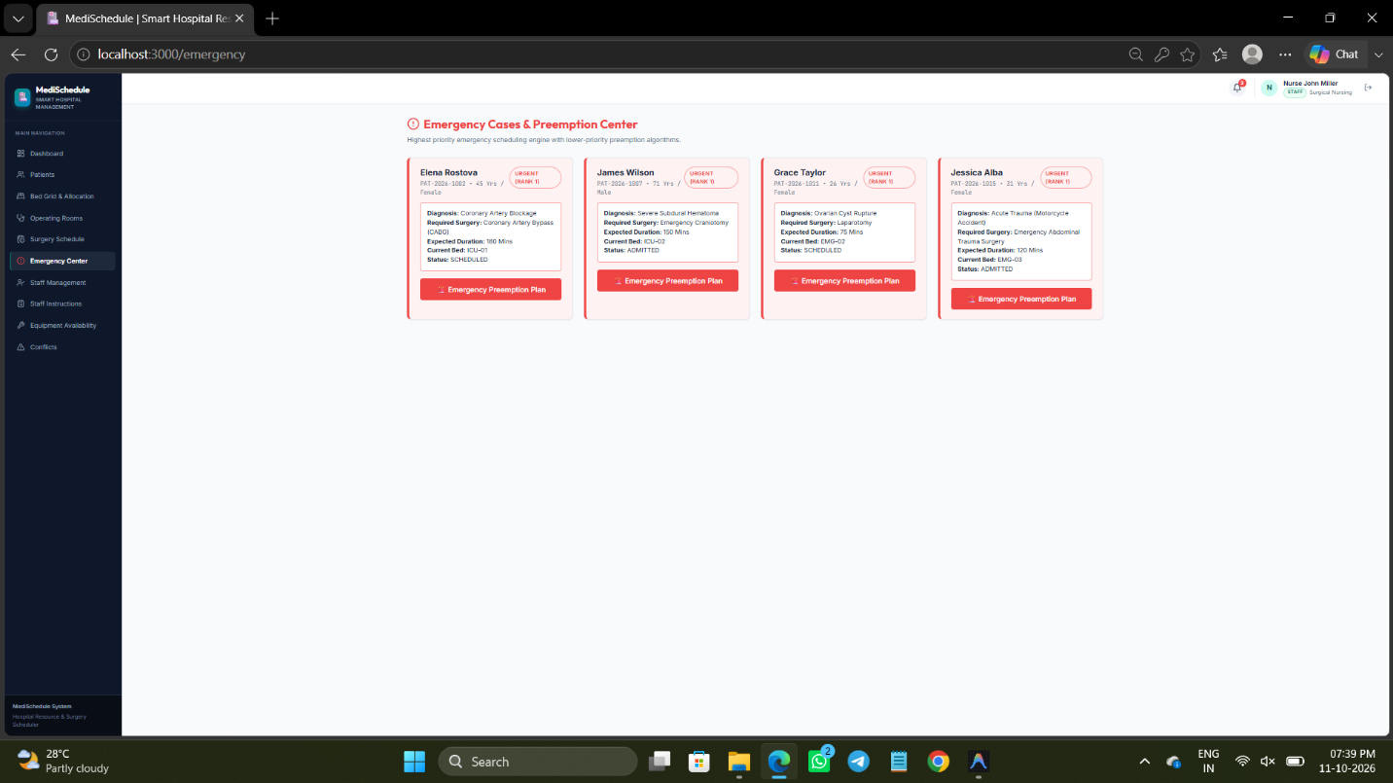

- CONCLUSION & FUTURE SCOPE
1. Conclusion
The MediSchedule – Smart Hospital Resource Management and Scheduling System was developed to improve the management and coordination of hospital resources through a centralized, user-friendly web application. The project addresses key challenges in hospital operations, including patient management, bed allocation, operating room scheduling, staff coordination, equipment availability, and emergency surgery prioritization.
The system integrates these functions to support efficient resource utilization, reduce scheduling conflicts, and improve the visibility of hospital operations. Features such as staff registration, administrator approval, role-based access control, staff instructions, and resource monitoring help establish a structured workflow for administrators and hospital staff. The application also demonstrates the practical application of Data Structures and Algorithms concepts to hospital scheduling and resource allocation.
Overall, the project achieves its primary objective of providing an integrated platform for hospital resource management. It demonstrates how software-based scheduling and centralized information management can support better coordination, informed decision-making, and more efficient hospital operations. The current frontend-based implementation provides a foundation for further development and real-world deployment.
2. Future Scope
The future development of MediSchedule can be organized into three stages.
2.1 Near-Term Enhancements
- Advanced Scheduling: Improve automatic surgery scheduling by considering patient priority, operating room availability, staff schedules, surgery duration, and equipment requirements.
- Waiting List Management: Introduce intelligent prioritization for patients waiting for beds, ICU admission, or surgery.
- Resource Timeline Visualization: Display bed and operating room availability across different time slots to identify scheduling conflicts quickly.
- Enhanced Notifications: Provide timely alerts for emergency cases, schedule changes, pending staff approvals, and equipment unavailability.
- Improved Analytics: Add detailed reports on bed occupancy, operating room utilization, patient waiting times, and staff workload.
2.2 Medium-Term Enhancements
- Backend and Database Integration: Migrate from browser-based localStorage to a centralized database and backend to support persistent, multi-user access across devices.
- Secure Authentication: Introduce secure password storage, account verification, session management, and stronger role-based authorization.
- Real-Time Synchronization: Ensure changes made by administrators are immediately reflected on authorized staff dashboards.
- Predictive Analytics: Use historical hospital data to estimate patient demand, surgery duration, bed requirements, and resource shortages.
- Emergency Impact Analysis: Automatically identify scheduling conflicts caused by emergency admissions and recommend alternative arrangements for administrator approval.
2.3 Long-Term Enhancements
- AI-Assisted Hospital Planning: Explore machine learning techniques to forecast resource demand and recommend efficient allocation strategies.
- IoT Integration: Connect compatible hospital monitoring devices to obtain real-time information about equipment and resource status.
- Inter-Hospital Resource Coordination: Extend the system to support resource visibility and coordination across multiple hospitals.
- Mobile Application: Develop mobile access for authorized administrators and staff to receive notifications and manage assigned tasks.
- Advanced Algorithm Research: Evaluate optimization, approximation, network-flow, and randomized algorithms on larger and more complex hospital scheduling datasets to improve scheduling quality and computational efficiency.

- REFERENCES

1. GE HealthCare – Centricity Perioperative Software: https://www.gehealthcare.com/en-in/products/healthcare-it/perioperative-software
2. Getinge – Torin OR Management: https://www.getinge.com/int/products/torin/
3. ORS AI – Operating Room Scheduling Software: https://orsai.app/
4. iHospital365 – Inpatient Department Management: https://ihospital365.com/features/ipd/
5. ZenoHosp – Hospital Management System: https://www.zenohosp.com/
6. Ostron HMIS – Hospital Management System: https://hmis.ostron.in/
7. HD MediDesk – Hospital Management System: https://www.hdmedidesk.com/
8. Uyirly – Hospital Management Software: https://www.uyirly.com/
9. KeyCode Technology – Hospital Management Software: https://keycodetech.com/products/hospital-management
10. Tapti HMIS – Hospital Management System: https://taptitechnology.com/

